**Conceptual Design: AI Smart Contract on Public Blockchain**

The conceptual design’s primary goal is to make a public blockchain GDPR compliant using artificial intelligence and smart contracts. This novel approach will further enhance the security, protection, and transparency of personal data management for users and requesting entities. As a public blockchain, the database will be fully decentralized with no organizations or entities controlling it. The proposed conceptual design is a foundational building block and is universal for future enhancements from hardware, software, algorithms, and overall data science improvements.

Furthermore, this design will create an ecosystem of data flow, data ownership, and compensation to parties who provide and entities whom make requests. Inversely, as user’s update their personal information on the blockchain, entities will be alerted of the changes and automated events could trigger based on conditions set on the smart contracts. And most importantly to GDPR, users control their data and can request deletion to entities who have stored copies of their personal data. This system would have a full audit trail with time stamps, events, transactions, and a ledger of funds exchanged.

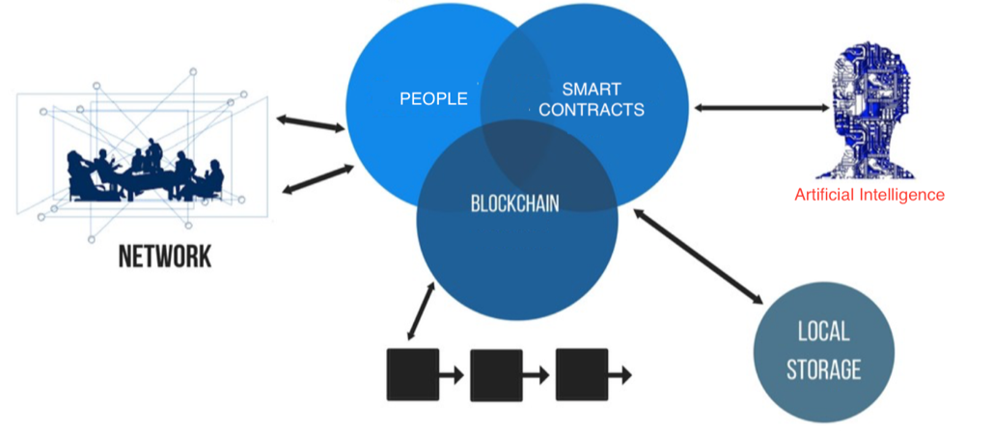

Figure 5: Conceptual Design

**System Overview**

As illustrated in figure 5, our contribution involves several components and technology. The following are the key stakeholders in our concept:

1. People: Users who are providing their personal data while performing creation, updates, and deletions.
2. Local Storage: Entities who are requesting copies of each user’s personal data and storing on their own private database.
3. Blockchain: A public blockchain that is fully decentralized, transparent, pseudonymity, and governed by collaborators.
4. Smart Contracts: A pre-defined program of conditions (set by users) on who, how, where, why, and when their personal information can be accessed. Also includes the compensation associated to every action (i.e. creation, update, deletions).
5. Artificial Intelligence: Predictions and classifications will provide insights for smart contracts to trigger and execute events.
6. Network: End-to-End communication on a fully decentralized network. Users will self-govern with no interference from 3rd parties – completely open source.

**Smart Contracts**

A smart contract facilitates, verifies, and executes the pre-defined conditions for each user’s data. Since a smart contract has no ability to think or reason, as its main purpose is to follow a set of instructions, our conceptual design provides artificial intelligence to in essence make it an intelligent contract. The following is a workflow diagram illustrating the stages of a smart contract:

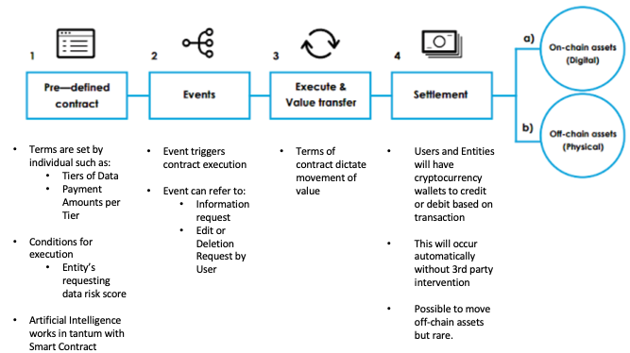

Figure 6: Smart Contract Workflow

**Artificial Intelligence**

The novel concept hinges on the data mining, machine learning, and data insights produced by the artificial intelligence (AI). The possibilities are endless, and applications of the models/algorithms produce will grow, leading to a new industry and opportunity. The following are a few ideas on how AI can serve to bring more intelligence to the smart contracts:

1. Predictive Risk Score of Entities (i.e. Trustworthiness, Security, Avg. Response Time to Requests)
2. Classification of Entities Industry (i.e. Retail, Financial, Social)
3. Categorization of Users and Their Data
4. Recommendation Engine on Compensation bi-directionally
5. Verification of Information for All Parties

**Analysis of AI**

**<this is where we insert our business understanding, exploration, models/algorithm, and insights from the SF restaurant data set>**

**Feasibility**

The current technology and sophistication of AI is still not a stage ready for automation. Network enhancements such as 5G will allow for better performance and reduce latency. Edge computing for IoT devices could reduce the load on computational resources while gathering more data points for AI to learn.

One of the major roadblocks to a public blockchain is the time required to verify and receive consensus on user data prior to an event executing. Another is adoption and confidence in a fully decentralize system. Both users and entities must be conditioned to have faith that a public blockchain is secure, transparent, and reliable.